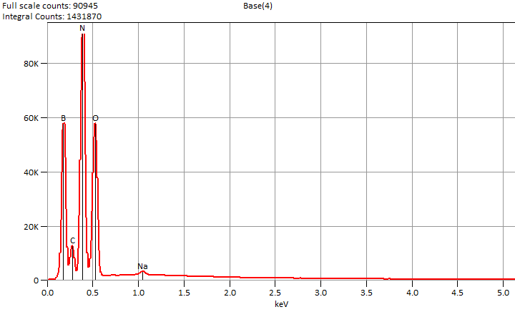

Live Time: 100.0 sec.

Mon Dec 02 11:36:12 2024

Filter Fit Chi Squared:366.296

Errors: +/- 1 Sigma

Correction Method: Proza (Phi-Rho-Z)

Acc.Voltage: 5.0 kV Take Off Angle: 37.8 deg.

Detector: UltraDry

WDS Results Unavailable for: Base(4)

|  |
| --- |
|  |

Quantitative Results for: Base(4)

|  |  |  |  |  |  |  |
| --- | --- | --- | --- | --- | --- | --- |
| ***Element***  ***Line*** | ***Int.***  ***Cps/nA*** | ***Int.***  ***Error*** | ***Weight %*** | ***Weight %***  ***Error*** | ***Atom %*** | ***Atom %***  ***Error*** |
| ***B K*** | 2926.7 | ± 27.95 | 15.7 | ± 0.2 | 20.4 | ± 0.2 |
| ***C K*** | 594.90 | ± 24.14 | 2.3 | ± 0.1 | 2.7 | ± 0.1 |
| ***N K*** | 4804.5 | ± 21.81 | 42.9 | ± 0.2 | 42.9 | ± 0.2 |
| ***O K*** | 3656.2 | ± 20.24 | 38.0 | ± 0.2 | 33.3 | ± 0.2 |
| ***Na K*** | 120.71 | ± 3.61 | 1.0 | ± 0.0 | 0.6 | ± 0.0 |
| ***Total*** |  |  | 100.0 |  | 100.0 |  |

ROI Results for: Base(4)

|  |  |  |
| --- | --- | --- |
| ***Operation*** | ***Gross Counts*** | ***Net Counts*** |